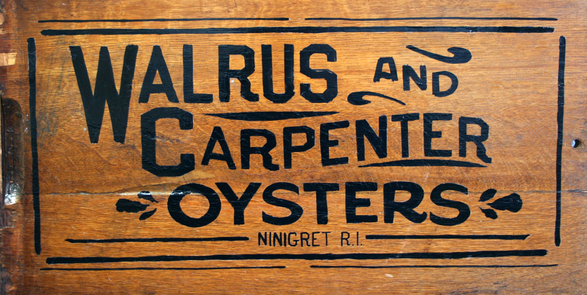

Job Title: Farm Worker

Description:

Walrus and Carpenter Oysters (WCO) is a vertically integrated ocean farm and distribution company. WCO is looking to hire hardworking, reliable, team oriented individuals to assist with the daily operations of our upweller nurseries, 6-acre oyster farm in Ninigret Pond in Charlestown, RI, 2-acre oyster farm in Dutch Harbor in Jamestown, RI and processing facility in Point Judith, RI.

Duties will include but are not limited to (1) cleaning and grading seed oysters in our upwellers, (2) grading oysters on our work barges, (3) rotating and drying of culture gear on the lease, and (4) processing oysters for market. In addition, there will be opportunities to assist and learn about the distribution, agro-tourism and catering divisions of the company.

At WCO we value innovation, systematic thinking, extreme organization, striving for perfection, follow-through, pushing yourself, not giving up, passion for what you do and having fun while you do it. We are looking for new team members who share these values and can grow with our company.

Farm Hands will report directly to the Farm Manager.

Compensation commensurate with experience

Requirements:

- Previous aquaculture, agriculture or commercial fishing experience is preferred
- Passion for aquaculture and local food production
- Personal transportation and valid drivers license required
- Must be able to lift 50lb
- Operation of boats and experience working on the water is a plus
- Able to work in adverse weather conditions and maintain a positive attitude
- Able to work independently and as a part of a team
- Flexible and able to adapt to any situation
- Ready to do whatever it takes to complete the job at hand
- Pleasant and upbeat personality
- A positive representative of Walrus and Carpenter Oysters

To Apply:

If you have questions or are interested in spending you summer waist deep in oyster cultivation paradise please send (1) a resume, (2) a cover letter and (3) a list of three references to:

steve@walrusandcarpenteroysters.com

